Required Knowledge Check 9.1: Polynomial Features on Multidimensional Data [20:00]
- Due Apr 24 at 12:29am

- Points 3

- Questions 3

- Available after Apr 16 at 9pm

- Time Limit None

- Allowed Attempts 3
Instructions
There is one required knowledge check on this page. Please scroll down to complete it.
Learning Outcome Addressed
- Identify the effect of polynomial features on Multidimensional data.
This is a required knowledge check and counts toward program completion.
This knowledge check reinforces the key concepts from Video 9.1: Polynomial Features on Multidimensional Data.
The average completion time for this activity is 20 minutes.
Attempt History
 | Attempt | Time | Score
KEPT | Attempt 2 | 2 minutes | 3 out of 3
LATEST | Attempt 2 | 2 minutes | 3 out of 3
 | Attempt 1 | 6 minutes | 2 out of 3
Answers will be shown after your last attempt
Score for this attempt: 3 out of 3
Submitted Apr 22 at 3:34pm
This attempt took 2 minutes.

Question 1
1 / 1 pts
If a dataframe has two columns, “horsepower” and “weight,” then the output of a polynomial features object with degree two will have which features?

[“hp”, “weight”, “hpLaTeX: ^2”, “hp weight”, “weightLaTeX: ^2”]
You are correct! The answer “[“hp”, "weight ","hpLaTeX: ^2”, “hp weight”, “weightLaTeX: ^2”]” is correct because these are the five output features of the polynomial features.

[“hp”, “weight”, “hpLaTeX: ^2”, “weightLaTeX: ^2”]

[“hp”, “weight”]

[“hp”, “weight”, “hp”, “hp weight”]

Question 2
1 / 1 pts
What is the result of increasing the degree parameter of the polynomial features on multidimensional data?

The number of polynomial features first decreases, then increases.

The number of polynomial features increases.

You are correct! The answer “The number of polynomial features increases” is correct because when the degree parameter of polynomial features is increased, it allows for the inclusion of higher-degree terms in the polynomial expansion.

The number of polynomial features decreases.

The number of polynomial features remains the same.

Question 3
1 / 1 pts
A given dataframe has two columns: “horsepower” and “weight.” How many features will a polynomial object of degree 3 have?

10

You are correct! The answer “10” is correct because in this case, you have “[“hp”, “weight”, “hp”, “hp weight”, “weight”]” in addition to horsepower cubed, horsepower squared multiplied by weight, horsepower multiplied by weight squared, weight cubed and finally the bias term added, which sum up a total of ten features.

5

9

2

Quiz Score: 3 out of 3

Required Knowledge Check 9.2: Sequential Feature Selection [20:00]
- Due Apr 24 at 12:29am

- Points 3

- Questions 3

- Available after Apr 16 at 9pm

- Time Limit None

- Allowed Attempts 3
Instructions
There is one required knowledge check on this page. Please scroll down to complete it.
Learning Outcome Addressed
- Utilize sequential feature selection to explore model complexity.
This is a required knowledge check and counts toward program completion.
This knowledge check reinforces the key concepts from Video 9.2: Sequential Feature Selection.
The average completion time for this activity is 20 minutes.
Attempt History
 | Attempt | Time | Score
LATEST | Attempt 1 | 7 minutes | 3 out of 3
Answers will be shown after your last attempt
Score for this attempt: 3 out of 3
Submitted Apr 22 at 3:45pm
This attempt took 7 minutes.

Question 1
1 / 1 pts
Which of the following statements best describes sequential feature selection?

Sequential feature selection involves testing each feature one by one and selecting the best features.

You are correct! The answer “Sequential feature selection involves testing each feature one by one and selecting the best features” is correct because sequential feature selection is a process where features are added or removed one at a time. The features are added one by one, each time selecting the feature that improves the model, until the k-features are selected.

Sequential feature selection involves random selection of features without any specific order.

Sequential feature selection involves testing all features simultaneously and selecting the best combination.

Sequential feature selection involves removing all features at once and then adding them back sequentially.

Question 2
1 / 1 pts
Imagine that you are given the following five features:
[“hp”, “weight”, “hp²”, “hp weight”, “weight²”].
The models built using only one of these features yield the following errors:
[“12.36”, “13.87”, “19.32”, “21.35”, “18.57”].
Which of the following features will be selected in the first iteration of sequential feature selection?

hp²

weight²

weight

hp

You are correct! The answer “hp” is correct since the error for "hp" is the lowest, it will be selected in the first iteration.

Question 3
1 / 1 pts
In forward sequential feature selection, the selected features are [“hp”, “weight”]. In the third iteration, the model contains , hp², hp*Weight, weight², and hp². It was observed that hp² has the lowest mean squared error. What would the final selected features be?

[“hp”, “weight”, “hp²”]
You are correct! The answer “[“hp”, “weight”, “hp²”]” is correct because the features “hp” and “weight” are already selected. In the third iteration, “horsepower²” has the lowest mean squared error, so it will also be a part of the final selected features.

[“hp”, “weight”]

[“hp”, “weight”, “weight²”]

[“hp”, “weight”, “hp*weight”]
Quiz Score: 3 out of 3

Required Knowledge Check 9.3: Sequential Feature Selection in Scikit-Learn [20:00]
- Due Apr 24 at 12:29am

- Points 3

- Questions 3

- Available after Apr 16 at 9pm

- Time Limit None

- Allowed Attempts 3
Instructions
There is one required knowledge check on this page. Please scroll down to complete it.
Learning Outcome Addressed
- Utilize sequential feature selection to explore model complexity.
This is a required knowledge check and counts toward program completion.
This knowledge check reinforces the key concepts from Video 9.3: Sequential Feature Selection in Scikit-Learn.
The average completion time for this activity is 20 minutes.
Attempt History
 | Attempt | Time | Score
KEPT | Attempt 3 | less than 1 minute | 3 out of 3
LATEST | Attempt 3 | less than 1 minute | 3 out of 3
 | Attempt 2 | less than 1 minute | 2 out of 3
 | Attempt 1 | 5 minutes | 2 out of 3
Score for this attempt: 3 out of 3
Submitted Apr 22 at 3:57pm
This attempt took less than 1 minute.

Question 1
1 / 1 pts
When using sequential feature selection in Python, what are the names of the two sets of indices that the data is divided into?
Correct!

Training and development indices

You are correct! The answer “Training and development indices” is correct because in sequential feature selection, the data is divided into a training set (which is used to train the model) and a development set (which is used to validate the model's performance). The development set helps to fine-tune the model and evaluate its performance before final testing.

Training and cross-validation indices

Validation and testing indices

Training and testing indices

Question 2
1 / 1 pts
When using sequential feature selection on a dataset with 12 features, how many models would you need to fit if you want to select five features?

42

38

32

Correct!

50

You are correct! The answer “50” is correct because to pick the first parameter, you have to fit 12 models. Then, for the second parameter, you have to fit 11 models. For the third parameter, you have to fit ten models. For the fourth parameter, you have to fit 9 models. Finally, you have to fit 8 models. Therefore, the total number of models is 12 + 11 + 10 + 9 + 8 = 50 models.

Question 3
1 / 1 pts
Why do sequential feature selection models that are built on the same dataset not return the same features in multiple runs?

The dataset is changing over time.

Correct!

The feature selection process involves randomness.

You are correct! The answer “The feature selection process involves randomness” is correct because Sequential feature selection methods often involve a degree of randomness or stochastic processes, such as in the initialization or in the selection steps. This randomness can lead to different features being selected in different runs even when the same dataset is used.

The models are overfitting to the training data.

The features themselves are unstable.

Quiz Score: 3 out of 3

Required Knowledge Check 9.4: How Regularization Works [20:00]
- Due Apr 24 at 12:29am

- Points 3

- Questions 3

- Available after Apr 16 at 9pm

- Time Limit None

- Allowed Attempts 3
Instructions
There is one required knowledge check on this page. Please scroll down to complete it.
Learning Outcome Addressed
- Use regularization parameter "alpha" in ridge regression.
This is a required knowledge check and counts toward program completion.
This knowledge check reinforces the key concepts from Video 9.5: How Regularization Works.
The average completion time for this activity is 20 minutes.
Attempt History
 | Attempt | Time | Score
LATEST | Attempt 1 | 8 minutes | 3 out of 3
Answers will be shown after your last attempt
Score for this attempt: 3 out of 3
Submitted Apr 22 at 4:38pm
This attempt took 8 minutes.

Question 1
1 / 1 pts
Which of the following statements about ridge regression is correct?

Ridge regression is used to prevent overfitting by adding a penalty to the regression coefficients.

You are correct! The answer “Ridge regression is used to prevent overfitting by adding a penalty to the regression coefficients” is correct because ridge regression includes a penalty term that reduces the magnitude of the regression coefficients, which helps to prevent overfitting by discouraging overly complex models.

In ridge regression, the penalty term does not depend on the size of alpha.

Ridge regression results in sparse models by eliminating some predictors.

Ridge regression does not use the alpha term for regularization.

Question 2
1 / 1 pts
In ridge regression, what is the alpha multiplied by the sum of ² + ² + ... + ² often called?

Regularization term

You are correct! The answer “Regularization term” is correct because it is added to the loss function to penalize large coefficients and prevent overfitting.

Residual sum of squares term

Error term

Bias term

Question 3
1 / 1 pts
In ridge regression, how does the size of the alpha term affect the model's behavior?

A larger alpha has no effect on the model's behavior.

A larger alpha decreases the penalty on the coefficients, leading to more overfitting.

A larger alpha reduces the complexity of the model by shrinking the coefficients toward zero.

You are correct! The answer “A larger alpha reduces the complexity of the model by shrinking the coefficients toward zero” is correct because a larger alpha increases the penalty on the size of the coefficients, which effectively shrinks them toward zero. This helps to reduce the complexity of the model and prevent overfitting.

A larger alpha increases the model's flexibility, allowing it to fit the training data more closely.
Quiz Score: 3 out of 3

Required Knowledge Check 9.5: Scaling [20:00]
- Due Apr 24 at 12:29am

- Points 3

- Questions 3

- Available after Apr 16 at 9pm

- Time Limit None

- Allowed Attempts 3
Instructions
There is one required knowledge check on this page. Please scroll down to complete it.
Learning Outcome Addressed
- Employ StandardScalar in ridge regularization.
This is a required knowledge check and counts toward program completion.
This knowledge check reinforces the key concepts from Video 9.6: Scaling.
The average completion time for this activity is 20 minutes.
Attempt History
 | Attempt | Time | Score
LATEST | Attempt 1 | 4 minutes | 3 out of 3
Answers will be shown after your last attempt
Score for this attempt: 3 out of 3
Submitted Apr 22 at 4:43pm
This attempt took 4 minutes.

Question 1
1 / 1 pts
Which technique is introduced to solve the problem of the penalty term penalizing small features heavily in ridge regression?

Normalization

Standardization

You are correct! The answer “Standardization” is correct because it involves scaling the features to have zero mean and unit variance, ensuring that all features contribute equally to the penalty term.

Feature selection

Data augmentation

Question 2
1 / 1 pts
What is the formula for the z-score?

z = x – mean / standard deviation

z = (x − mean) / standard deviation

You are correct! The answer “z = (x − mean) / standard deviation” is correct because this is the formula for calculating the z-score.

z = x − mean

z = x / standard deviation

Question 3
1 / 1 pts
Why is the StandardScaler used in ridge regression?

To ensure that all features contribute equally to the penalty term by scaling features to have zero mean and unit variance.

You are correct! The answer “To ensure that all features contribute equally to the penalty term by scaling features to have zero mean and unit variance” is correct because StandardScaler is used to standardize the features by scaling them to have a mean of zero and a standard deviation of one. This ensures that all features contribute equally to the penalty term in ridge regression, preventing small-scale features from being heavily penalized.

To remove irrelevant features from the dataset.

To increase the size of the dataset by generating new data points.

To convert categorical variables into numerical variables.

Quiz Score: 3 out of 3

Required Knowledge Check 9.6: GridSearchCV [20:00]
- Due Apr 24 at 12:29am

- Points 3

- Questions 3

- Available after Apr 16 at 9pm

- Time Limit None

- Allowed Attempts 3
Instructions
There is one required knowledge check on this page. Please scroll down to complete it.
Learning Outcome Addressed
- Apply GridSearchCV to select the optimal value for alpha.
This is a required knowledge check and counts toward program completion.
This knowledge check reinforces the key concepts from Video 9.7: GridSearchCV.
The average completion time for this activity is 20 minutes.
Attempt History
 | Attempt | Time | Score
LATEST | Attempt 1 | 6 minutes | 3 out of 3
Answers will be shown after your last attempt
Score for this attempt: 3 out of 3
Submitted Apr 22 at 5:08pm
This attempt took 6 minutes.

Question 1
1 / 1 pts
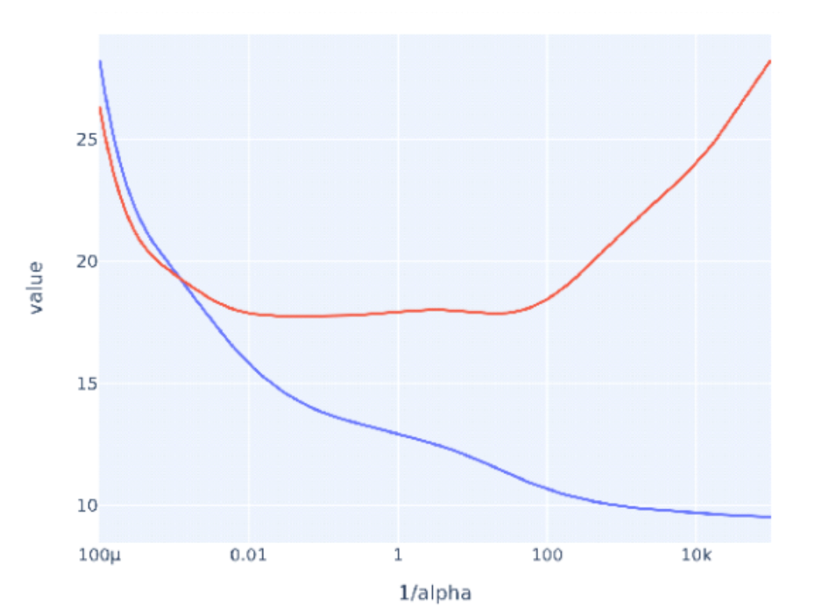
In the given graph, what does the blue curve for alpha values on the x-axis and the MSE on the y-axis represent?

Validation MSE

Test MSE

Training MSE

You are correct! The answer “Training MSE” is correct because with the increase in alpha values, the MSE decreases for training.

Dev MSE

Question 2
1 / 1 pts
What can scikit-learn’s GridSearchCV be used to find?

The best scaling technique for the data

The optimal set of hyperparameters for a given model

You are correct! The answer “The optimal set of hyperparameters for a given model” is correct because GridSearchCV is used to perform an exhaustive search over a specified parameter grid to find the best set of hyperparameters for a given model based on cross-validation.

The most suitable model architecture for deep learning

The most relevant features to include in the model

Question 3
1 / 1 pts
In the Python function GridSearchCV(), what is the purpose of the param_grid parameter?

To define the cross-validation splitting strategy

To set the random state for reproducibility

To specify the grid of hyperparameters to search over

You are correct! The answer “To specify the grid of hyperparameters to search over” is correct because the param_grid parameter in GridSearchCV is used to define the grid of hyperparameters that will be exhaustively searched to find the optimal combination for the model.

To provide the scoring measure for evaluating the model

Quiz Score: 3 out of 3

Required Knowledge Check 9.7: LASSO Regression [20:00]
- Due Apr 24 at 12:29am

- Points 3

- Questions 3

- Available after Apr 16 at 9pm

- Time Limit None

- Allowed Attempts 3
Instructions
There is one required knowledge check on this page. Please scroll down to complete it.
Learning Outcome Addressed
- Select features using Lasso regression.
This is a required knowledge check and counts toward program completion.
This knowledge check reinforces the key concepts from Video 9.8: LASSO Regression.
The average completion time for this activity is 20 minutes.
Attempt History
 | Attempt | Time | Score
LATEST | Attempt 1 | 3 minutes | 3 out of 3
Answers will be shown after your last attempt
Score for this attempt: 3 out of 3
Submitted Apr 22 at 5:53pm
This attempt took 3 minutes.

Question 1
1 / 1 pts
What is LASSO regression also known as?

Ridge regression

L1 regularization

You are correct! The answer “L1 regularization” is correct because LASSO regression is also known as L1 regularization. It adds a penalty equal to the absolute value of the magnitude of coefficients to the loss function.

L2 regularization

Elastic net regularization

Question 2
1 / 1 pts
What is the penalty term in L1 regularization?

The sum of the squares of the parameters multiplied by alpha

The product of the parameters and alpha

The sum of the parameters multiplied by alpha

The sum of the absolute values of the parameters multiplied by alpha

You are correct! The answer “The sum of the absolute values of the parameters multiplied by alpha” is correct because in L1 regularization, the penalty term is indeed the sum of the absolute values of the parameters (coefficients) multiplied by a regularization parameter alpha. This penalty encourages sparsity in the model by driving some coefficients to be exactly zero, effectively selecting a simpler model.

Question 3
1 / 1 pts
What is the regression that forces the parameters to be smaller and, in most circumstances, forces many of its parameters to zero?

Linear regression

LASSO regression

You are correct! The answer “LASSO regression” is correct because this type of regression forces the parameters to be smaller and, in most cases, forces many of its parameters to zero.

Ridge regression
Logistic regression

Quiz Score: 3 out of 3
Required Knowledge Check 9.8: k-fold Cross-Validation [20:00]
- Due Apr 24 at 12:29am

- Points 3

- Questions 3

- Available after Apr 16 at 9pm

- Time Limit None

- Allowed Attempts 3
Instructions
There is one required knowledge check on this page. Please scroll down to complete it.
Learning Outcome Addressed
- Evaluate the differences between leave-one-out cross-validation, K-fold cross-validation, and holdout cross-validation.
This is a required knowledge check and counts toward program completion.
This knowledge check reinforces the key concepts from Video 9.9: K-fold Cross Validation.
The average completion time for this activity is 20 minutes.
Attempt History
 | Attempt | Time | Score
LATEST | Attempt 1 | 2 minutes | 3 out of 3
Answers will be shown after your last attempt
Score for this attempt: 3 out of 3
Submitted Apr 22 at 6:10pm
This attempt took 2 minutes.

Question 1
1 / 1 pts
In simple cross-validation, the dataset is divided into how many datasets?

3

5

4

2

You are correct! The answer “2” is correct because simple cross-validation is divided into two sets: training sets and validation sets.

Question 2
1 / 1 pts
What does the k represent in k-fold cross-validation?

The number of new features the model will have

The number of columns the dataset has

The number of rows the dataset has

The number of folds to split a dataset into

You are correct! The answer “The number of folds to split a dataset into” is correct because k represents the number the data is divided into.

Question 3
1 / 1 pts
In k-fold cross-validation, if k equals 5, which fold would be the validation set in the third iteration?

First fold
Second fold
Fourth fold
Third fold

You are correct! The answer “Third fold” is correct because in the first iteration, the first fold will be the validation set, and in the second iteration, the second fold will be the validation set. Similarly, in the third iteration, the third fold will be the validation set.
Quiz Score: 3 out of 3

